**STONEBRIDGE HOMEOWNERS ASSOCIATION MEETING**

June 6, 2024

7 pm

Lunar Bowl

**Present**: Phil Leslie (President), Jon Mitchell (Vice President), Derek Webb (Architectural Committee), Jorge Gonzales (Architectural Committee Chair), Gary Hough, Viv Glenn-Hough (Secretary), Dave Phillips (Architectural Committee), Justin Barnes

**Finances**: the following amounts were in our bank accounts:

* Checking 1726.93 as of 6-6-24
* Savings $17,019.03 as of 6-6-24
* Country Club Bank (for HA-KC use) not available from HA-KC on this day

Phil made a motion to roll most of the savings account to a certificate of deposit. Phil and Hugh will check for a financial facility that has the best interest rate. Motion passed unanimously.

We don’t have a new delinquency list for today’s meeting, but Phil said there are approximately 10 homeowners who are in default of their HOA dues. One owner has been asked to paint their house a number of times but that has not been done yet. The board determined that appropriate action as necessary for all homeowners will continue to be pursued.

**HOA Complaints**: An anonymous complaint was received about a van that had been converted to an RV has been parked in a driveway for several months. We will ask Doug from HA-KC to investigate and send a letter that this is in violation of the HOA Covenants and Restrictions (and possibly Blue Springs city code as well).

**HOA Architectural Committee Requests**: Jorge provided a spreadsheet of the most recent requests (below). Derek was recognized for stepping up to help the Architectural Committee recently with many of the requests that have come in for approval.

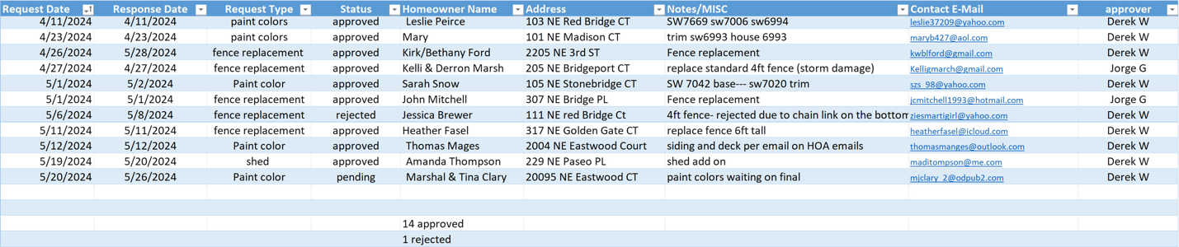

**Other Items**: Reminder that Neighborhood Garage Sale dates are scheduled for June 12-15, 2024. It will be noted on our website and Facebook page, as well as garage sale groups on Facebook.

Dumpster Day has been had to be rescheduled from June 8 to June 22 due to a scheduling issue, from 9 am-noon at Eastwood Dr and Eastwood Ct. HOA dues must be currently paid up to participate.

Our annual Block Party is set up for September 28, 2024; in case of rain, October 5 will be our backup date. We went over a tentative list of which board member will handle the items that need to be taken care of and decided to once again grill hotdogs and hamburgers. We will give out tickets out for ice cream this year, to have a better handle on ice cream sales.

Phil: arrange for ice cream vendor and bounce house (if we have enough volunteers to assist with the bounce house), gift cards for door prizes and fishing derby winners

Jon: city permits, police and fire department scheduling

Gary: judge the fishing derby

Viv: Signup Genius for bounce house volunteers, arrange for ballon artist and face painter

The next HOA meeting will be held on Thursday, August 8, 2024 at 7 pm at Lunar Bowl in their conference room. Stonebridge HOA residents and children are welcome. Please come meet your HOA board and neighbors.

Respectfully submitted,

*Viv Glenn-Hough, Secretary*